Joint Industry Project Agreement

THIS JOINT INDUSTRY PROJECT AGREEMENT, effective upon date of last signature, is entered into BETWEEN

- OLI Systems, Inc. (“OLI”), a New Jersey corporation with offices at 240 Cedar Knolls Road, Suite 301, Cedar Knolls, New Jersey 07927 and,

- __________________ (“Member”), a company organized under the laws of ________________ with a principal place of business at ____________________ (and collectively with each other additional third party that executes a counterpart or joiner to this Agreement, becoming a Party to this Agreement as a “Member” in order to participate in the HF Alkylation Project after the commencement date of such project, the “Members”).

WHEREAS, OLI is seeking to create a Joint Industry Project (“JIP”) to participate in the development of the necessary interaction parameters between hydrofluoric acid (HF), hydrocarbons, and H₂O, and to develop case studies and case templates using this updated model to simulate the alkylate and HF recovery process, and

WHEREAS, Member is seeking to engage, participate and collaborate with OLI on the JIP “Corrosion in the HF Alkylation Process” (the “HF Alkylation Project”), details of which can be referenced in Schedule 1, (the “HF Alkylation Project Proposal”).

NOW, THEREFORE, the Parties agree as follows:

1. DEFINITIONS and INTERPRETATION

1.1 In this Agreement and the Recitals the following terms shall have the meanings set out below (unless the context requires otherwise):

“Affiliate” means, with respect to any Party, a company, partnership or other legal entity which directly or indirectly controls, is controlled by, or is under common control with, a Party. The term “control” means the ownership, directly or indirectly, of fifty percent (50%) or more of the equity or voting rights in a company, partnership or legal entity.

“Agreement” means this Joint Industry Project Agreement, the attached Schedule 1, and all other exhibits and schedules attached and made a part hereto.

“Claim” means any claim, demand, cause of action (whether arising in contract, tort including without limitation in negligence or otherwise), suit, judgment, remedies, recoveries, debts, liens, loss, expense, proceeding, penalty, award of damages or liability (including without limitation reasonable legal fees, costs and expenses and sums paid by way of settlement or compromise).

“Confidential Information” means any and all know how, information, materials, samples, reports and technical records, data, ideas, experience, rules-of-thumb, product specifications, or trade secrets provided by any Disclosing Party to any other Party pursuant to this Agreement or otherwise relating to the business of the Disclosing Party, whether in written, graphical, electronic, oral or visual form, that is either marked “Confidential”, or with similar legend clearly identifying the Disclosing Party’s proprietary interest, including, without limitation all reports, recommendations and results of the HF Alkylation Project, or is otherwise of a nature that would reasonably be deemed to be confidential or proprietary, provided that if such information is orally, visually or otherwise disclosed via a non-tangible medium, it is contemporaneously identified as proprietary and confidential and is subsequently reduced to a tangible form marked “Confidential” or with similar legend clearly identifying the Disclosing Party’s proprietary interest and provided to the other Party within thirty (30) days of such disclosure.

“HF Alkylation Project” means the Corrosion in the HF Alkylation Process Project for the research and development of certain technology, including the creation, modification, usage, and know-how regarding certain equipment, techniques, systems and methods, as set out in the HF Alkylation Project Proposal.

“HF Alkylation Project Proposal” means the detailed plan for the conduct of the HF Alkylation Project set out in Schedule 1, as amended in accordance with Clause 3 from time to time.

“Intellectual Property Rights” means any and all of the following intellectual property rights relating to or in connection with a Party’s business, products or services, and all related technology, designs, specifications, prototypes and all improvements or modifications thereto or derivations thereof, and all Confidential Information and proprietary data of a Party: (i) patents, patent applications, patent disclosures and all related continuation, continuation-in-part, divisional, reissue, reexamination, utility model, certificate of invention and design patents, patent applications, registrations and applications for registrations, (ii) trademarks, service marks, trade dress, Internet domain names, logos, trade names and corporate names and registrations and applications for registration thereof, (iii) copyrights and registrations and applications for registration thereof, (iv) computer software, data and documentation, (v) inventions, ideas, trade secrets and confidential business information, whether patentable or nonpatentable and whether or not reduced to practice, know-how, manufacturing and product processes and techniques, designs, plans, sketches, images, strategies, forecasts, components, research and development information, copyrightable works, financial, marketing and business data, pricing and cost information, business and marketing plans and customer and supplier lists and information, (vi) other proprietary rights relating to any of the foregoing (including remedies against infringements thereof and rights of protection of interest therein under the laws of all jurisdictions), and (vii) copies and tangible embodiments thereof.

“Party” means a party to this Agreement.

“Project IP” means the Intellectual Property Rights made or generated solely as a result of the HF Alkylation Project, including, without limitation, a private databank developed for the purpose of subsequent integration with OLI’s software products and services, and all documentation created in connection with the HF Alkylation Project comprised of experimental data, results of calculations and other technical specifications, outcomes and conclusions.

“Senior Management Personnel” means in relation to any Party, any person employed by a Party or any of its Affiliates as a director, a corporate officer or who occupies a senior management position in the organization of such Party with direct responsibility.

“Technical Steering Committee” means the committee established for the management of the HF Alkylation Project in accordance with Clause 3.

“Willful Misconduct” means an intentional or reckless disregard by Senior Management Personnel of good practice or any of the terms of this Agreement in utter disregard of avoidable and harmful consequences but shall not include any act, omission error of judgment or mistake made in the exercise in good faith of any function, authority or discretion vested in or exercisable by such Senior Management Personnel and which in the exercise of such good faith is justifiable by special circumstances, including safeguarding of life, property or the environment and other emergencies.

1.2 The headings of Schedules and Clauses in this Agreement are included for convenience and ease of reference only and are not included in this Agreement for the purposes of the construction thereof.

1.3 Any reference to any agreement, covenant, representation or warranty contained in this Agreement includes any assignment, novation, supplement or amendment thereto entered into from time to time.

1.4 Any reference to Clauses, Schedules or exhibits are references to Clauses in and Schedules and exhibits to this Agreement and all such Schedules and exhibits are incorporated herein and made a part hereof by reference.

1.5 In the event of conflict, the provisions of the main body of this Agreement shall control over the provisions of any Schedule, except where expressly provided in the main body of this Agreement to the contrary or where any Schedule has been signed by all Parties and expressly overrides one or more provisions of the main body of this Agreement.

1.6 Where the context requires, words denoting the singular shall also include the plural and vice versa.

2. OBLIGATIONS

OLI Obligations:

  - OLI shall carry out the HF Alkylation Project as outlined in Schedule 1 (“The HF Alkylation Project Proposal”), and shall perform its duties and obligations with all due diligence, care and skill in accordance with all applicable laws and in accordance with the HF Alkylation Project Proposal and the requirements of this Agreement. OLI shall be responsible for providing performance hereunder by qualified personnel, on a timely basis and in a professional manner, and will conform to the standards of performance customarily exercised by competent professionals performing services similar to those contemplated by this Agreement.

Member Obligations:

  - Each Member shall participate and collaborate with OLI to carry out the HF Alkylation Product, as outlined in Schedule 1 (“The HF Alkylation Project Proposal”), and shall perform its duties and obligations with all due diligence, care and skill in accordance with all applicable laws and in accordance with the HF Alkylation Project Proposal and the requirements of this Agreement. Each Member shall be responsible for providing performance hereunder by qualified personnel, on a timely basis and in a professional manner, and will conform to the standards of performance customarily exercised by competent professionals performing services similar to those contemplated by this Agreement.

2.3 Each Member shall remit timely payment to OLI in accordance with Schedule 1.

2.4 No Member shall publish or otherwise disclose any of the results of the HF Alkylation Project (which are Confidential Information) without the prior consent of OLI. For the avoidance of doubt, OLI shall have the right, at its sole discretion, to disclose or publish any or all of the results of the HF Alkylation Project at any time and for any purpose, and to incorporate and integrate such results and the Project IP into OLI’s proprietary software products and services.

3. TECHNICAL STEERING COMMITTEE

3.1 The Parties shall establish a Technical Steering Committee, and each Party shall, at its own cost, provide a representative to attend all meetings of the Technical Steering Committee, who shall be a person engaged in the management of the HF Alkylation Project on behalf of such Party. Technical Steering Committee meetings may be in person or via teleconference. The Technical Steering Committee shall:

- monitor progress of the HF Alkylation Project;

- provide advice to the Parties relating to the conduct of the HF Alkylation Project;

- review the results and recommendations of HF Alkylation Project reports, and provide guidance regarding the satisfactory performance of the work; and

- suggest changes to the HF Alkylation Project Proposal.

3.2 The Technical Steering Committee shall consist of one representative from each Party, who shall notify the other Party of the identity of its representative and of any replacement.

3.3 The Technical Steering Committee will convene meetings as necessary, and shall vote as a body on the recommendations, guidance and suggestions set forth in Clause 3.1; provided that OLI shall retain sole control and autonomy with respect to the direction and performance of the HF Alkylation Project and no vote of the Technical Steering Committee shall be binding upon OLI. Each representative shall have one vote at meetings of the Technical Steering Committee and matters shall be decided by the affirmative vote of a majority of the persons present at the meeting, other than the following actions by the Technical Steering Committee which shall require in all cases the affirmative consent of the Technical Steering Committee member designated by OLI:

(a) any recommended change to the HF Alkylation Project Proposal; and

- any recommendation for the early termination of the HF Alkylation Project, and of this Agreement.

4. CONFIDENTIALITY

4.1 With respect to any Confidential Information of another Party arising solely as a result of the HF Alkylation Project or disclosed by another Party pursuant to this Agreement, each Party receiving such Confidential Information hereunder (the “Recipient”) shall, during the term of this Agreement and for a period of five (5) years thereafter:

(a) keep secret and confidential all Confidential Information disclosed to it by any other Party (the “Disclosing Party”), and shall not disclose or permit it to be made available to any person, firm or company (except to the Affiliates of the Recipient and its and their employees or sub-contractors who shall be obliged by the Recipient to treat such Confidential Information as confidential in the same manner and to an equivalent extent as provided for herein with regard to confidentiality, disclosure and use) without the Disclosing Party’s prior written consent;

(b) use the Confidential Information solely in connection with the HF Alkylation Project including its further development or commercialization or exploitation and for no purpose other than expressly permitted under this Agreement; and

(c) upon withdrawal from the HF Alkylation Project, or upon termination of this Agreement, either return the Confidential Information and all copies of it to the Disclosing Party, or at the Disclosing Party’s request, confirm in writing to the Disclosing Party that all Confidential Information and all copies of it have been destroyed, except as may be required by law.

4.2 Nothing in Clause 4.1 shall apply to any information or data which:

(a) at the time of its disclosure is in, or subsequently comes into, the public domain (other than due to a breach of this Agreement);

(b) is disclosed by the Disclosing Party on a non-confidential basis;

(c) the Recipient can demonstrate was lawfully in the possession of the Recipient or any of its Affiliates or sub-contractors prior to the date of the disclosure;

(d) the Recipient can demonstrate is subsequently received by the Recipient or any of its Affiliates or sub-contractors from a third party without any obligation of confidentiality; or

(e) is required to be disclosed by the Recipient or any of its Affiliates or sub-contractors by applicable law or order of a court of competent jurisdiction or government department or agency or by any recognized stock exchange, provided that the Recipient provides the Disclosing Party reasonable advance notice of such required disclosure and discloses Confidential Information only to the extent required.

For the avoidance of doubt, nothing in this Clause 4 shall prohibit OLI from including the Project IP or any component thereof in future public releases of OLI’s software products, as specified in Schedule 1, or from embedding such Project IP into OLI’s software for OLI’s internal use.

5. INTELLECTUAL PROPERTY RIGHTS

5.1 Except as otherwise expressly provided in this Clause 5, nothing in this Agreement is intended to, nor shall it be interpreted to, grant or convey to any Member any license, interest or rights, express or implied, to any of the Project IP, including, without limitation, the simulation parameters, correlations and the application templates and related software capabilities and documentation developed as Project IP in connection with the HF Alkylation Project. Each Member acknowledges that, as between the Parties, all ownership and Intellectual Property Rights with respect to the Project IP, including, without limitation, the right to unlimited reuse of the applicable capabilities, including the integration of these parameters into third party software, are and shall remain the sole and exclusive property of OLI, and OLI shall retain all right, title and interest in and to the foregoing. No Member shall appropriate the Project IP, or challenge OLI’s ownership thereof, and each Member agrees not to sell, transfer, lease, publish, disclose, display, disseminate or otherwise make available any part of the Project IP other than as expressly permitted in connection with the HF Alkylation Project without the prior written consent of OLI.

5.2 During the term of this Agreement, OLI hereby grants to each Member a limited, non-exclusive, non-transferable, non-sublicensable, revocable, royalty-free right and license to the use of the Project IP developed as part of the HF Alkylation Project either (i) in accordance with such Member’s duties, obligations and performance under Schedule 1 or (ii) for such Member’s internal business purposes (but, for the avoidance of doubt, not for the purposes of marketing, promotion or commercialization to third parties). For the avoidance of doubt, a Member may access and use the Project IP, as integrated into OLI’s software products and services, for such Member’s commercial use, solely through the purchase of a software license from OLI through a separate license agreement. While OLI will retain all ownership rights with respect to Project IP and the licensed software products and services, a Member purchasing any such separate software license shall have ownership rights to the individualized simulation results, data and other work product generated by such Member’s use of the OLI software in accordance with the terms of the applicable software license.

5.3 Each Member shall ensure that all work and performance by such Member related to the HF Alkylation Project shall only be undertaken by employees of the Member and/or by persons whose contracts with the Member provide for the assignment to the Member by such persons of all Intellectual Property Rights created by them during the course of their duties under such contracts.

5.4 During the confidentiality period as specified in Clause 4 and Schedule 1, each Party shall keep the Project IP secret and confidential and shall not disclose or permit it to be made available to any person without the prior written consent of OLI.

5.5 Each Member shall ensure that any successor, assignee or other transferee in ownership of such Member remains bound by and subject to, and acknowledges the obligation to adhere to and implement, all of the Member’s obligations hereunder with respect to the respective ownership of Intellectual Property Rights of the Parties as set forth herein.

6. INDEMNIFICATION; LIMITATION ON LIABILITY; DISCLAIMER OF WARRANTIES

6.1 Each Member, severally but not jointly, shall indemnify OLI and OLI’s Affiliates, officers, directors, employees and agents harmless from and against all third party Claims, to the extent such third party Claims arise out of, are based on, or result from (i) the Willful Misconduct or gross negligence of such Member or its Affiliates, (ii) the improper use or modification of the Project IP by such Member or its Affiliates, or (iii) any breach by such Member of its representations, warranties and covenants set forth herein.

6.2 OLI shall indemnify each Member and its Affiliates, officers, directors, employees and agents harmless from and against all third party Claims, to the extent such third party Claims arise out of, are based on, or result from (i) the Willful Misconduct or gross negligence of OLI or its Affiliates, (ii) any allegations of infringement of Intellectual Property Rights with respect to the Project IP, except to the extent that any such third party Claim results from the improper use or modification of the Project IP by any Member or its Affiliates, or (iii) any breach by OLI of its representations, warranties and covenants set forth herein.

6.3 A Party claiming indemnity under this Clause 6 (the “Indemnified Party”) shall give written notice to the Party from whom indemnity is being sought (the “Indemnifying Party”) promptly after learning of such Claim. The Indemnified Party shall provide the Indemnifying Party with reasonable assistance, at the Indemnifying Party’ s expense, in connection with the defense of the claim for which indemnity is being sought. The Indemnifying Party shall have the right to assume and conduct the defense of the claim with counsel of its choice; provided the Indemnified Party may participate in and monitor such defense with counsel of its own choosing at its sole expense; provided further, that the Indemnifying Party shall seek the prior written consent (such consent to not be unreasonably withheld, delayed or conditioned) of any such Indemnified Party as to any settlement which would require any payment by such Indemnified Party, would require an admission of legal wrongdoing in any way on the part of an Indemnified Party, or would affect an amendment of this Agreement. So long as the Indemnifying Party is actively defending the claim in good faith, the Indemnified Party shall not settle any such claim without the prior written consent of the Indemnifying Party. If the Indemnifying Party does not assume and conduct the defense of the claim as provided above, (i) the Indemnified Party may defend against, and consent to the entry of any judgment or enter into any settlement with respect to the claim in any manner the Indemnified Party may deem reasonably appropriate (and the Indemnified Party need not consult with, or obtain any consent from, the Indemnifying Party in connection therewith), and (ii) the Indemnifying Party will remain responsible to indemnify the Indemnified Party as provided in this Clause 6.

6.4 IN NO EVENT SHALL A PARTY BE LIABLE TO THE OTHER PARTY, WHETHER IN CONTRACT, TORT (INCLUDING NEGLIGENCE) OR OTHERWISE, ARISING FROM OR RELATING TO THIS AGREEMENT, FOR ANY SPECIAL, CONSEQUENTIAL, INCIDENTAL, PUNITIVE, EXEMPLARY OR INDIRECT DAMAGES, INCLUDING, WITHOUT LIMITATION, ANY DAMAGES RESULTING FROM LOSS OF PROFITS, BUSINESS OR GOODWILL, REGARDLESS OF ANY NOTICE OF THE POSSIBILITY OF SUCH DAMAGES. NOTWITHSTANDING THE FOREGOING, IN NO EVENT SHALL THE TOTAL LIABILITY OF A PARTY HEREUNDER EXCEED, IN THE AGGREGATE, THE AMOUNT ACTUALLY PAID BY AND/OR DUE FROM A MEMBER PURSUANT TO THIS AGREEMENT AND SCHEDULE 1 DURING THE TWELVE (12) MONTH PERIOD PRIOR TO THE DATE OF THE APPLICABLE CLAIM.

6.5 OLI has agreed to participate in the HF Alkylation Project on the basis that it may be able to provide useful information to Members based on its previous experience and expertise. OLI shall not have any liability whatsoever, (including, without limitation, liability in contract or in tort, including in negligence), for any information, assistance and/or advice provided to any Member or any of its Affiliates in connection with or arising from its participation in the HF Alkylation Project nor in respect of any other involvement of any kind in the HF Alkylation Project by OLI, and each Member shall, in addition to the indemnity set forth in Clause 6.1, indemnify and hold harmless OLI from and against any and all third party Claims incurred by such Member or any of its Affiliates in connection with or arising from the provision by OLI (or its employees or agents) of any such information, assistance and/ or advice.

6.6 No provision in this Agreement shall seek to exclude or limit the liability of any Party for fraudulent misrepresentation.

6.7 Any insurance policy covering obligations and/or liabilities arising out of this Agreement by a Member shall contain a waiver of subrogation against the other Parties.

6.8 OLI hereby makes the following disclaimers of warranties:

- EXCEPT AS EXPRESSLY PROVIDED HEREIN, THE PROJECT IP AND ALL TECHNOLOGY AND INTELLECTUAL PROPERTY RIGHTS PROVIDED BY OLI HEREUNDER WITH RESPECT TO THE HF ALKYLATION PROJECT, INCLUDING, WITHOUT LIMITATION, ALL DATA, CONTENT AND SOFTWARE INTEGRATED OR INCORPORATED THEREIN, ARE PROVIDED “AS IS” AND “AS AVAILABLE” AND WITHOUT ANY REPRESENTATIONS, WARRANTIES OR CONDITIONS OF ANY KIND.

- WITHOUT LIMITING CLAUSE 6.8(a) ABOVE, OLI EXPRESSLY DISCLAIMS ALL WARRANTIES AND CONDITIONS, WHETHER EXPRESS, IMPLIED OR STATUTORY, INCLUDING, WITHOUT LIMITATION, THE WARRANTIES OR CONDITIONS OF MERCHANTABILITY, FITNESS FOR A PARTICULAR PURPOSE, TITLE, NON-INFRINGEMENT AND INFORMATIONAL CONTENT, AND ANY AND ALL WARRANTIES WITH RESPECT TO THE PROJECT IP AND ALL TECHNOLOGY AND INTELLECTUAL PROPERTY RIGHTS PROVIDED BY OLI HEREUNDER, OR ARISING FROM TRADE USAGE, COURSE OF DEALING OR COURSE OF PERFORMANCE.

- WITHOUT LIMITED CLAUSE 6.8(a) ABOVE, EXCEPT AS OTHERWISE EXPRESSLY PROVIDED HEREIN, OLI MAKES NO REPRESENTAITON, WARRANTY OR COVENANT, EXPRESS OR IMPLIED, (i) AS TO THE ACCURACY OR RELIABILITY OF ANY INFORMATION, CONTENT OR SERVICE PROVIDED BY OR THROUGH OLI, AND (ii) AS TO ANY MEMBER’S OR ANY THIRD PARTY’S USE OR QUIET ENJOYMENT OF ANY OF THE PROJECT IP OR ANY SOFTWARE PRODUCTS OR SERVICES INTO WHICH SUCH PROJECT IP IS INCORPORATED OR INTEGRATED, AND OLI SHALL NOT BE LIABLE, EITHER DIRECTLY OR INDIRECTLY, OR AS AN INDEMNITOR OF A MEMBER, AS A CONSEQUENCE OF ANY IMPAIRMENT OF SUCH USE OR QUIET ENJOYMENT. OLI MAKES NO WARRANTY THAT THE PROJECT IP OR ANY INTELLECTUAL PROPERTY RIGHTS PROVIDED HEREUNDER WILL MEET ANY MEMBER’S OR ANY THIRD PARTY’S EXPECTATIONS, REQUIREMENTS OR NEEDS.

7. TERM, TERMINATION AND WITHDRAWAL

7.1 The initial term of this Agreement shall be as defined in Schedule 1, and subject to any extension pursuant to Clause 3 or earlier termination pursuant to Clause 7.4, shall continue until and shall automatically terminate on the date of completion of the HF Alkylation Project in accordance with the HF Alkylation Project Proposal.

7.2 If any Party (the “Defaulting Party”) commits a material breach of this Agreement, and does not, within fourteen (14) days of receipt of written notice of the breach from either the Technical Steering Committee or the non-breaching Party (if the same be capable of remedy), remedy such breach to the reasonable satisfaction of the Technical Steering Committee or the non-breaching Party, as applicable, the Defaulting Party shall from the date of such breach until such date of remedy thereof (if the breach is capable of remedy), have no rights whatsoever under this Agreement, and, without limitation, shall not be entitled to attend and vote at meetings of the Technical Steering Committee, and shall not be entitled to any benefit from the commercialization or exploitation of the results of the HF Alkylation Project but shall remain subject to its obligations and liabilities under this Agreement.

7.3 For the avoidance of doubt, where any Defaulting Party shall have remedied its breach in a timely manner, the rights of, and the benefits available to, such Defaulting Party shall be reinstated on a retroactive basis.

7.4 This Agreement shall automatically terminate on the earliest of the following events:

(a) all Parties withdraw from the Agreement in writing;

(b) the Technical Steering Committee determines in writing that the HF Alkylation Project cannot be completed within the budget set out in the HF Alkylation Project Proposal, and the Technical Steering Committee does not approve an increase in such budget, and no alternative funds are available;

- a Member convenes a meeting of its creditors or a proposal is made for a voluntary insolvency arrangement or a proposal is made for any other composition, scheme or arrangement with its creditors or if it shall be unable to pay its debts, or if a trustee, receiver, administrative receiver or similar officer is appointed in respect of all or any part of its business or assets or if a petition is presented or meeting convened for the purposes of considering a resolution or other steps are taken for the winding up of such Member;

(d) the date that is nine (9) months after the effective date of this Agreement in the event the HF Alkylation Project has not commenced by such date, unless otherwise agreed in writing by the Parties;

(e) upon written notice from the non-breaching Party in the event the Defaulting Party commits a material breach of this Agreement, and does not, within fourteen (14) days of receipt of written notice of the breach from either the Technical Steering Committee or the non-breaching Party (if the same be capable of remedy), remedy such breach to the reasonable satisfaction of the Technical Steering Committee or the non-breaching Party, as applicable.

7.5 If this Agreement is terminated in accordance with Clause 7.4(d), OLI shall, within fourteen (14) days following the date of termination, repay each Member all sums paid hereunder.

7.6 The terms and conditions set forth in Clauses 2.4, 4, 5, 6, 7, 9, 10 and 12 shall survive termination of this Agreement.

8. FORCE MAJEURE

8.1 No failure or omission by any Party to carry out or observe any of the stipulations, conditions or obligations to be performed hereunder shall, (except for failure to pay) be deemed to be in breach of this Agreement to the extent such failure or omission arises in connection with a Force Majeure Event. For the purposes hereof, “Force Majeure Event” means any act of God, enemy or hostile action, war, blockade, insurrection, riot, epidemic, flood, earthquake, nuclear or radiation activity or fall-out, civil disturbance, explosion, lightning, fire or other casualty, labor strike or industrial dispute, or any other cause beyond the reasonable control of the Party asserting the existence of a Force Majeure Event.

9. ASSIGNMENT

9.1 No Member shall assign or otherwise transfer nor purport to assign or otherwise transfer this Agreement or any of its rights hereunder, in whole or in part, without the prior written consent of OLI, which consent shall not be unreasonably withheld or delayed.

10. TAXES

10.1 Each Member shall pay all taxes assessed against it in connection with this Agreement and shall indemnify OLI from any and all Claims relating to taxes on income or profits and other taxes assessed or levied against the Member or against OLI on account of any payment made or due to OLI or its contractors hereunder. Additionally, the Member shall defend, indemnify and hold OLI harmless from all taxes assessed or levied against or on account of fees, wages, salaries or other benefits paid to the Member’s’ employees or consultants or employees of its sub-contractors, and taxes assessed or levied against or on account of any property or equipment of the Member or its sub-contractor including customs, excise, occupation and other like tax imposts, any fines, penalties or interest thereon.

11. ETHICAL BEHAVIOUR

11.1 Each Party covenants and undertakes with each other Party neither it nor its Affiliates, nor any of their respective directors, officers, employees or agents has, to the best of its actual knowledge and belief, or will make, offer, or authorize with respect to the matters which are the subject of this Agreement, any payment, gift, promise or other advantage, whether directly or through any other person or entity, to or for the use or benefit of any person, where such payment, gift, promise or advantage would violate (a) United States law or (b) the laws relating to corruption applicable to such covenanting Party.

12. GENERAL LEGAL PROVISIONS

12.1 This Agreement, including all Schedules and exhibits hereto, constitutes the entire agreement and understanding of the Parties and supersedes any previous agreement between the Parties in relation to the subject matter hereof.

12.2 Each of the Parties acknowledges and agrees that in entering into this Agreement it does not rely on and shall have no remedy in respect of any statement, representation, warranty or understanding (whether negligently or innocently made) of any person (whether a Party to this Agreement or not) other than as expressly set out in this Agreement as a representation or warranty.

12.3 The failure to exercise or delay in exercising a right or remedy provided by this Agreement or by law does not constitute a waiver of such right or remedy or a waiver of other rights or remedies or of the future enforcement of any rights.

12.4 A waiver of a breach of any of the terms of this Agreement or of a default under this Agreement does not constitute a waiver of any other breach or default and shall not affect the other terms of this Agreement.

12.5 This Agreement shall be binding upon and inure for the benefit of the Parties, their successors and permitted assigns.

12.6 This Agreement shall be governed by and construed under the laws of the State of New Jersey, without giving effect to any choice of laws principles that would require the application of the laws of a different state.

12.7 Nothing in this agreement shall create or shall be construed as creating a partnership of any kind or an association or as imposing upon any Party any duty, obligations or liability of a partnership nature.

12.8 Nothing contained in this Agreement shall be construed to give any Member an ownership interest in any of OLI's software, assets, intellectual property or confidential information. In no event shall this Agreement be construed as an assignment or sale or other transfer of title of any asset now or hereafter owned by OLI.

12.9 The Parties agree that information and software disclosed under this Agreement is subject to the laws and regulations of the Government of the United States of America for the export and re-export of technical data (including classified information) and equipment and products therefrom, including where required the issuance and renewal of validated export licenses, and each party agrees to comply with the terms of all applicable regulations, laws, and/or licenses.

12.10 This Agreement may be executed in any number of counterparts and by different Parties hereto on separate counterparts, each of which when so executed shall be an original but all the counterparts shall together constitute one and the same instrument.

12.11 In the event of any dispute, claim, question, or disagreement (a “dispute”) arising from or relating to this Agreement or the breach thereof, the Parties hereto shall use their best efforts to resolve the dispute to the mutual satisfaction of the Parties through good faith business discussions. Should such discussions fail to resolve the dispute within a period of thirty (30) days, then, upon notice by either Party to the other, all disputes, claims, questions, or differences (including issues relating to the formation of the agreement and the validity of this arbitration clause) shall be finally settled by binding arbitration administered by the American Arbitration Association (“AAA”) in accordance with the provisions of its Commercial Arbitration Rules, as well as the Federal Rules of Civil Procedure and the Federal Rules of Evidence, and judgment on the award rendered by the arbitrator(s) may be entered in any court having jurisdiction thereof.

The arbitration panel shall consist of a single arbitrator mutually agreed upon by the Parties, unless otherwise agreed to by the Parties. The place of arbitration shall be New Jersey. If the Parties are not able to decide upon a neutral third-party arbitrator within thirty (30) days of the request for arbitration, then the AAA shall select an arbitrator having at least twenty (20) years of experience in intellectual property matters. All proceedings will be conducted in English. The Parties agree to hold the entirety of the arbitration proceedings, including knowledge of the existence of any dispute or controversy, completely confidential except for such disclosures as might be required by law.

This arbitration provision does not limit or affect the right of either Party to seek from any court having jurisdiction any interim, interlocutory, or provisional relief that is necessary to protect the rights or property of that Party. Alternatively, either Party may apply to the AAA pursuant to the AAA Optional Rules for Emergency Measures seeking injunctive relief until the arbitration award is rendered or the controversy is otherwise resolved.

[Signature Page to Follow]

IN WITNESS WHEREAS, the parties hereto have executed this Joint Industry Project Agreement on the date first set forth above.

[MEMBER] OLI SYSTEMS, INC.

BY: ______________________________ BY: _____________ ________
Name Andre Anderko, CTO

DATE: ___________________________ DATE: __________________ _

SCHEDULE 1

HF Alkylation Project Proposal

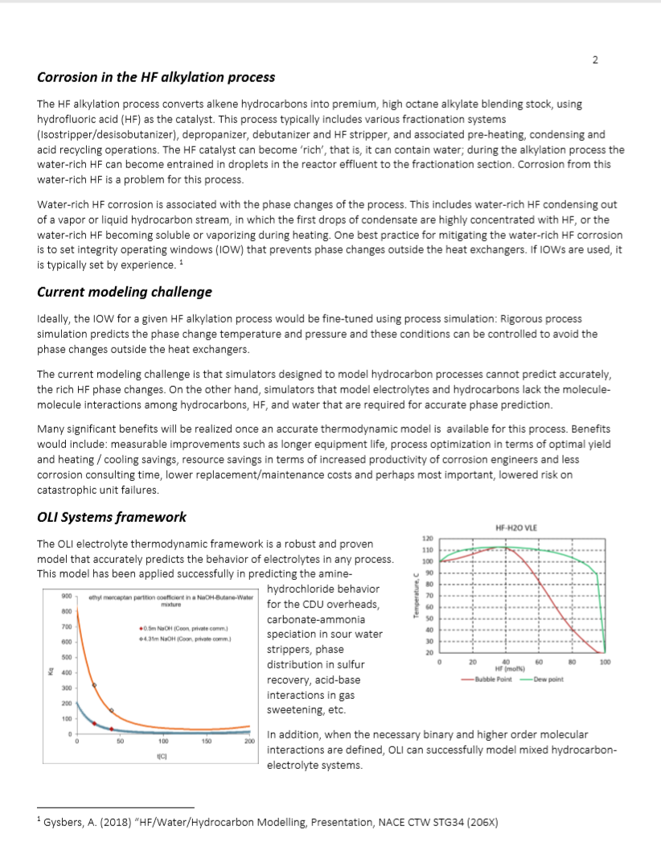
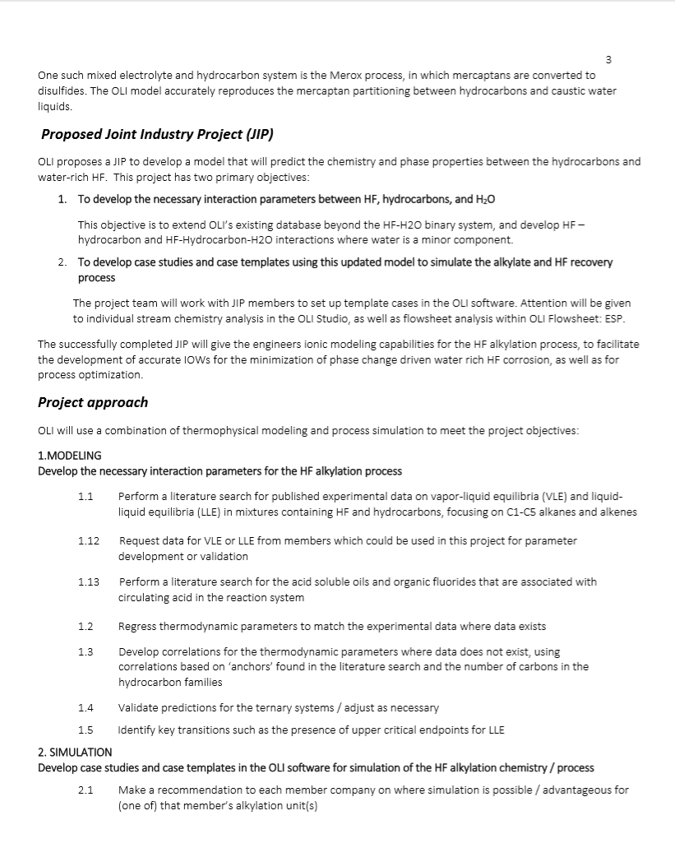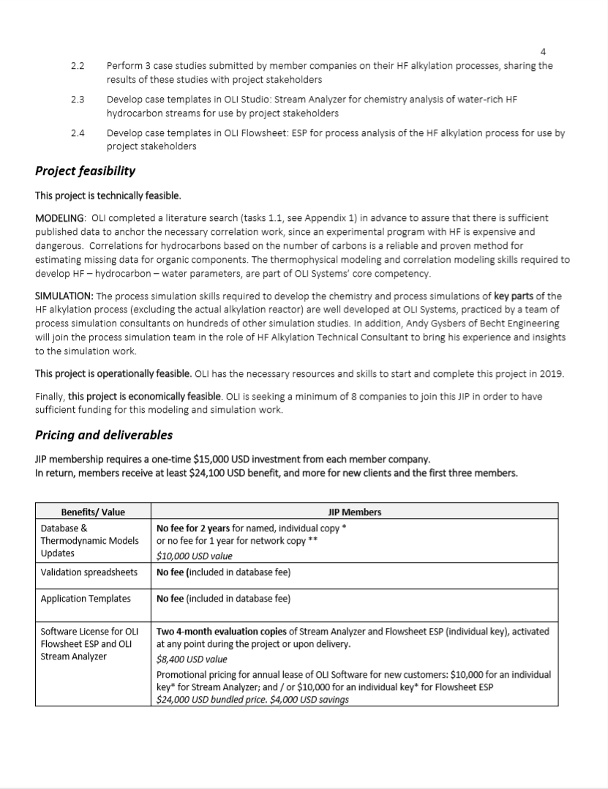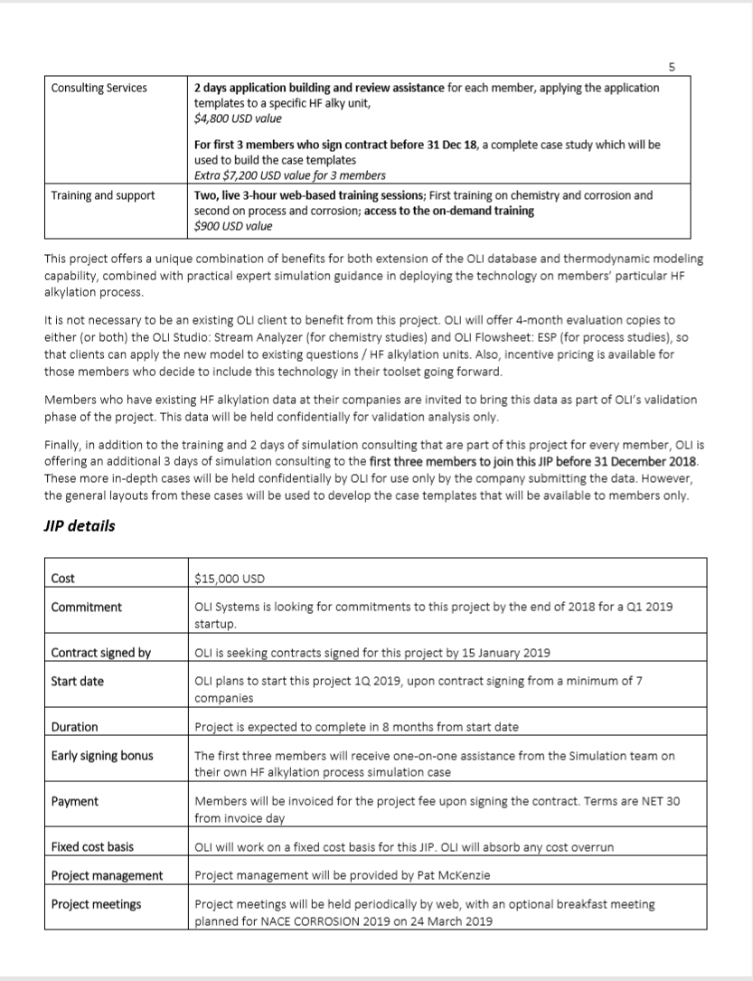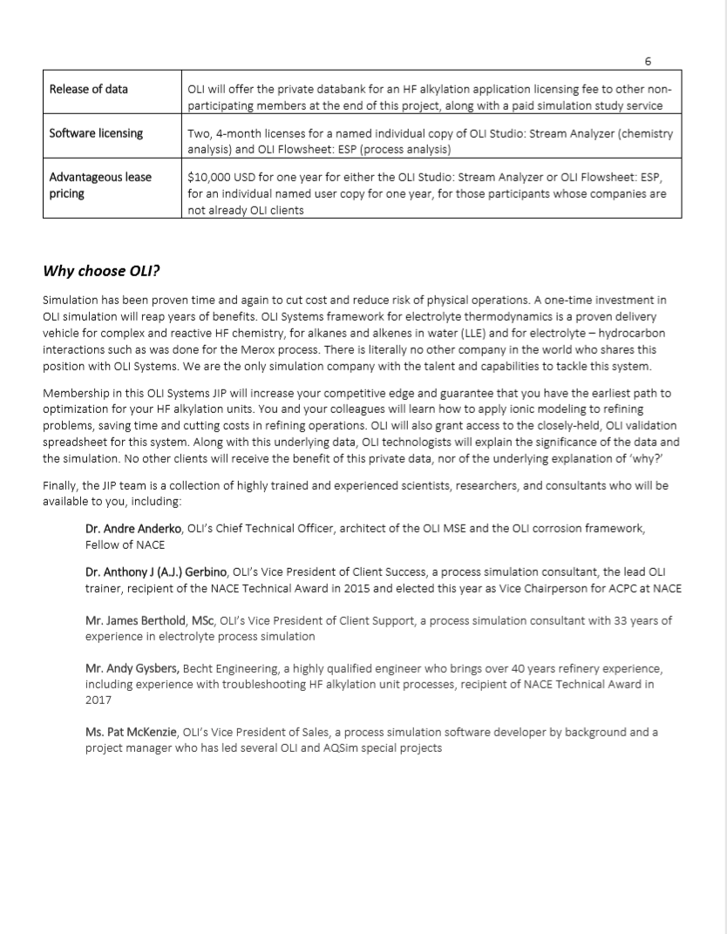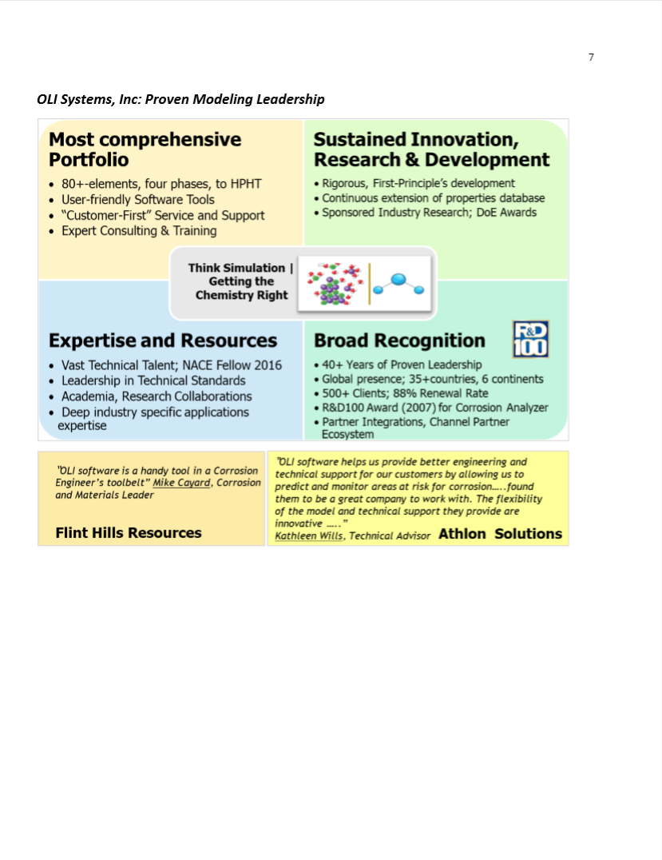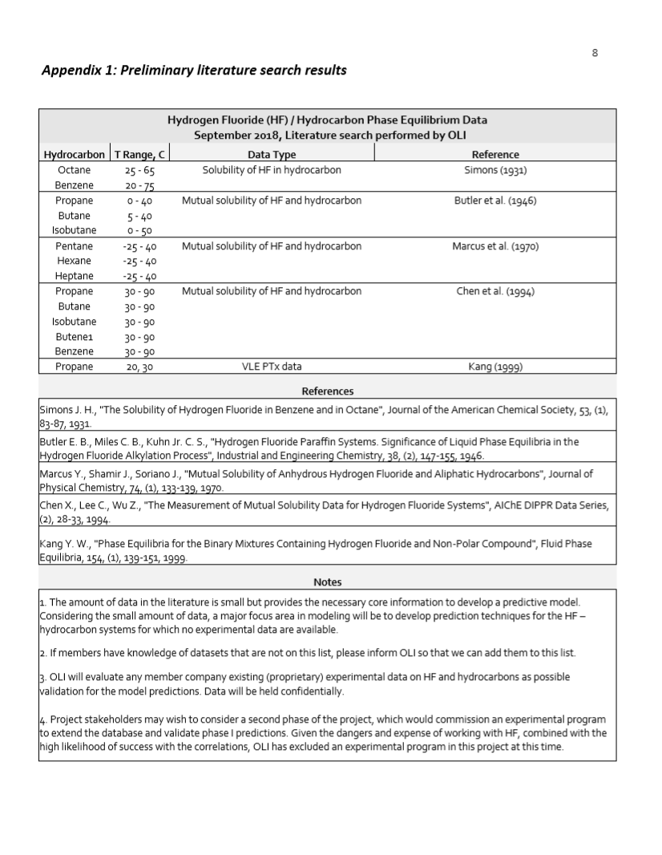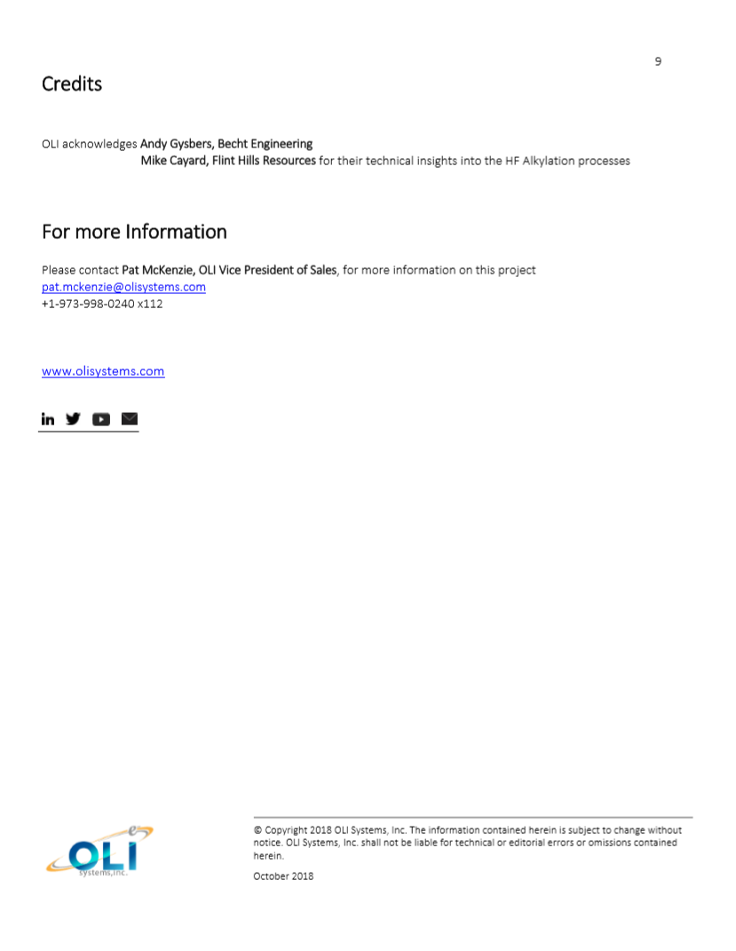
End of HF Alkylation Project Proposal

